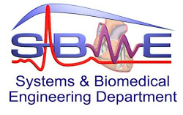

Course**: MRI**

Team members:

|  |  |  |  |
| --- | --- | --- | --- |
| Name | SEC | BN | Seating No. |
| Remon Alber | 1 | 31 | 53031 |
| Rawan Sayed | 1 | 30 | 53030 |
| Sara Adel | 1 | 35 | 53035 |
| Mohammed ElMoatasem | 2 | 18 | 53063 |

Submitted to Dr. Inas



Contrast Enhanced Modified T1 Weighted Imaging



**ABSTRACT**

Contrast enhancement in radiology is a ubiquitous concept, Refer to any process by which the apparent difference between adjacent imaging structures is improved by administering contrast media/agents. This includes trying to differentiate between the normal structures. Many different types vary from one modality to another. Also, contrast enhancement can refer to features of irregular body lesions. The diffusion of the contrasting agents from the bloodstream to body tissues is limited physiologically. In certain pathologies, such as cancer, new irregular blood vessels can form which appear to be leakier than normal capillaries, resulting in a much more visible lesion on contrast-enhanced scans. On post-processing image. Improving the conspicuity of lesions is achieved by redistributing the grayscale of the images in a non-linear fashion to improve the separation of subtle or obscure variations in pixel intensity into a more visually discernible distribution, thus taking advantage of the physiological attributes of human vision.

**Table of Contents**

Introduction 1

Sequence Objective 1

Sequence Description 1

T1-weighted imaging: 1

**T1-weighted image sequence** 2

Contrast-Enhanced Modified T1 Weighted image 2

**Contrast-Enhanced T1 weighted Imaging Sequence:** 3

Paramagnetic Contrast Agents: 3

Improving MRI Contrast 4

Image Quality and Artifacts 5

Image Quality 5

Image Artifacts: 6

➢ Subclavian Pseudo-stenosis Artifact 6

➢ Scanning Too Late/Venous Contamination 7

➢ Scanning Too Early/Ringing (Maki) Artifact 7

Preparation to perform enhanced modified T1 image 8

Usefulness of Contrast-enhanced T1-weighted imaging 9

(DWT-SVD) Method 10

Steps to execute main computational process of the proposed algorithm for enhancing the low contrast brain 11

Results 12

Applications 13

References 14

**List of Figures**

Figure 1:Modified version of T1-weighted imaging 1

Figure 2: T1-weighted imaging 1

Figure 3:Spin Echo T1-weighted image 2

Figure 4: T1 weighted image without contrast agent 2

Figure 5: T1 weighted image with contrast agent 3

Figure 6:Types of contrast agents 3

Figure 7: A) Enhanced T1weighted image , B) T1 weighted image 5

Figure 8:Subclavian Pseudo-stenosis Artifact 6

Figure 9:Scanning Too Late/Venous Contamination 7

Figure 10:Scanning Too Early/Ringing (Maki) Artifact 8

Figure 11:Difference between T1 weighted image with/without GAD 8

Figure 12:Image DWT decomposition; (a) Original T1-w MR image, (b) LL, LH, HL and HH sub-band images. 10

Figure 13:Global block diagram of the proposed enhancement algorithm 11

Figure 14:Enhanced images using different contrast enhancement methods and one of them (DWT-SVD) Method 12

Figure 15:glioblastoma resection Edema and hemorrhage along resection cavity representing post-surgical changes 13

# **Introduction**

The contrast-enhanced (CE) MRI provides in vivo physiological information that conventional imaging methods cannot obtain. Generally, this information is derived using models to reflect the distribution of the contrast agent inside the body. The results however depend on the fit quality obtained with the model chosen. Therefore, to avoid working on physiologically irrelevant parameters one has to check the fit quality.

**Sequence Objective**

It makes the outlines of tumors much simpler and more noticeable and enhances the comparison of hemorrhage affected boarders areas. The difference between T1-weighted image and enhanced T1-weighted image is that for T1-weighted image, The emphasis is placed on the T1 signal using short TR and TE times but for contrast-enhanced T1-weighted image, A paramagnetic contrast agent (usually gadolinium-based) is administered and has the effect of reducing T1 relaxation time and thus increasing the signal intensity.

# **Sequence Description**

This sequence is a modified version of T1-weighted imaging, so, before we start talking about this sequence we have to take a short brief about the T1-weighted imaging sequence.

Figure 1:Modified version of T1-weighted imaging

**T1-weighted imaging:**

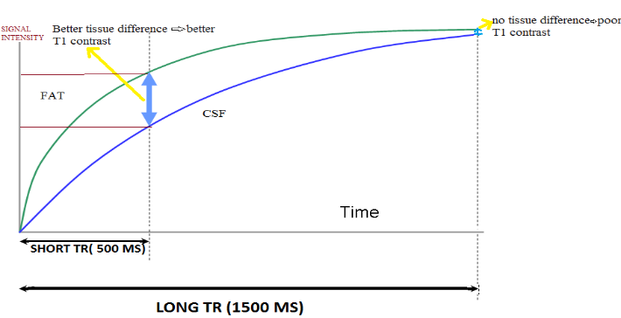

In this type of sequence, the contrast of the image depends mainly on the T1 properties of the tissues, That doesn’t mean that the T2 property and the proton density of the tissues don’t affect the image contrast, but they don’t affect the same as T1 property.

In the construction of this type of imaging, we take the **TR** (repetition time) too short, and **TE** (echo time) also too short.

Figure 2: T1-weighted imaging

## **T1-weighted image sequence**

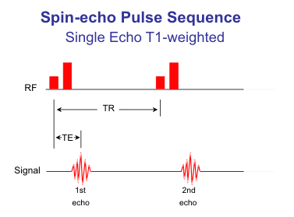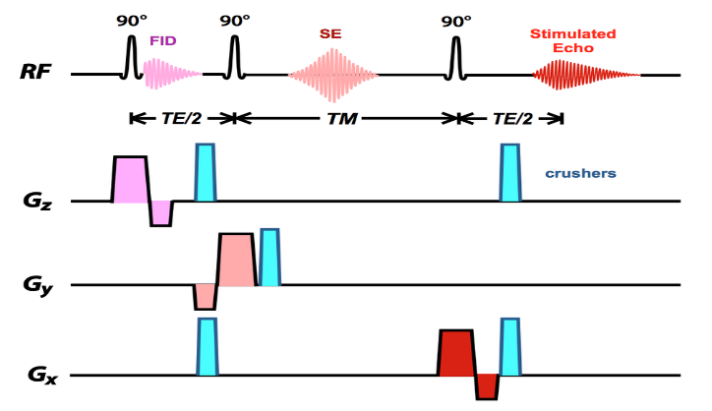As our sequence is the T1 weighted image sequence we will take a short look at this sequence(spin sequence).

Figure 3:Spin Echo T1-weighted image

**Contrast-Enhanced Modified T1 Weighted image**

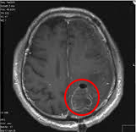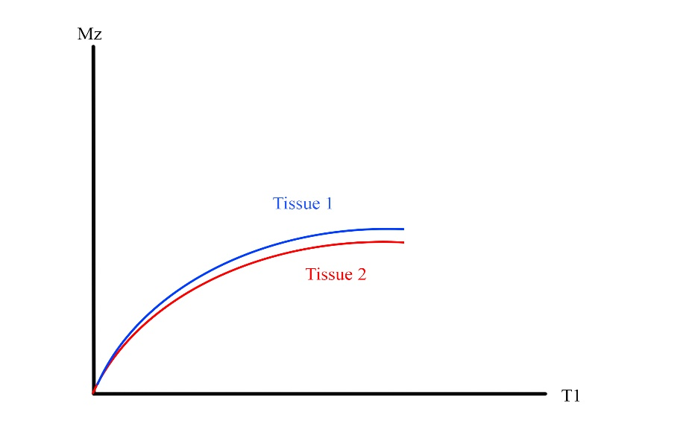In some cases, it is difficult to illustrate the difference between the two types of tissues for example tumor and normal tissue due to the similarity in the T1 values.

Figure 4: T1 weighted image without contrast agent

As shown it’s hard to show the difference between the two tissues. So, to solve this problem we inject paramagnetic contrast agent in the tumor, The free electrons of the agent interact with the hydrogen protons, this interaction called PEDI proton-electron dipole interaction which takes place if only there is a similarity in size between proton and agent’s electrons, specifically if it is less than 3 Angstrom, this effect is all or none effect that means it occurs or no interaction occurs at all, That's called spin-lattice relaxation, that means increasing of the probability of the protons to lose energy and return to a normal state.

This changes the properties of the tissue, T1 time becomes smaller than the normal and now it's easier to see the difference between them.

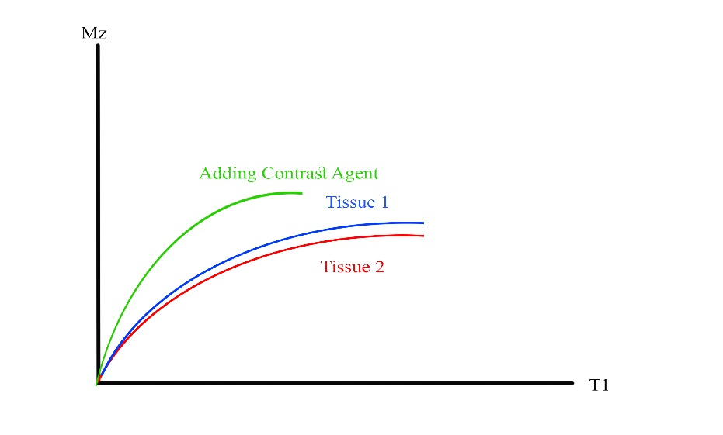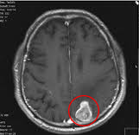

## **Contrast-Enhanced T1 weighted Imaging Sequence:**

As said before the sequence is the same as the T1 weighted image sequence because the difference here is not in the sequence but the properties of the tissue, so in this sequence we take TR very short to see the difference in T1 property.

Figure 5: T1 weighted image with contrast agent

**Paramagnetic Contrast Agents:**

MRI contrast agents used to improve visualization of internal body structures in magnetic resonance imaging. Gadolinium-based compounds are the most widely used for contrast enhancement.

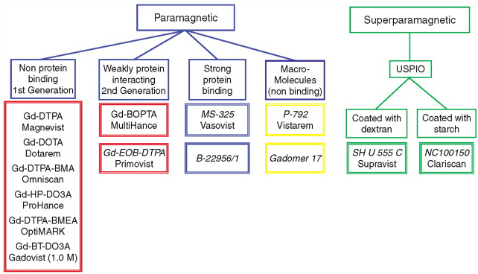Depending on the subject of interest, MRI contrast agents may be administered by injection into the bloodstream or orally. Oral administration best suits G.I. Tract scans, while for most other scans intravascular administration is more useful. An array of agents of all kinds regularly improves scans.

Figure 6:Types of contrast agents

There are many ways to classify MRI contrast agents, including by their:

* Chemical composition
* Route of administration
* Magnetic Properties
* Effect on image

The gadolinium ion is useful because it has seven unpaired electrons, which is the largest possible number of unpaired electron spins for an atom.

Gadolinium molecules shorten the duration of spin-lattice relaxation (T1) of voxels they are present in. Consequently they have a clearer signal on T1-weighted images. There are a variety of applications of this:

* Focal lesion diagnosis (e.g. tumor, abscess, metastasis);
* Vessel imaging in MR-angiography or MR-venography
* Calculation of Parameters of MR Perfusion

Gadolinium agents can be categorized into:

* Extracellular fluid agents
* Blood pool agents
* Hepatobiliary agents
* Agents approved by FDA

There are other contrast agents:

* Iron Oxide
* Iron Platinum
* Manganese

# **Improving MRI Contrast**

Magnetic Resonance Imaging is naturally depending on the signal intensity, which is based on certain parameters, which include: Proton density, Transverse relaxation time (T2), Longitudinal relaxation time (T1), Repetition time (TR) and Echo time (TE).

We can change the contrast of the resulted image by manipulating these parameters, and we did so to enhance the normal T1 weighted image to achieve our sequence which is far better in the image quality.

For a normal T1-weighted image, the emphasis is placed on the T1 signal using short TR and TE.

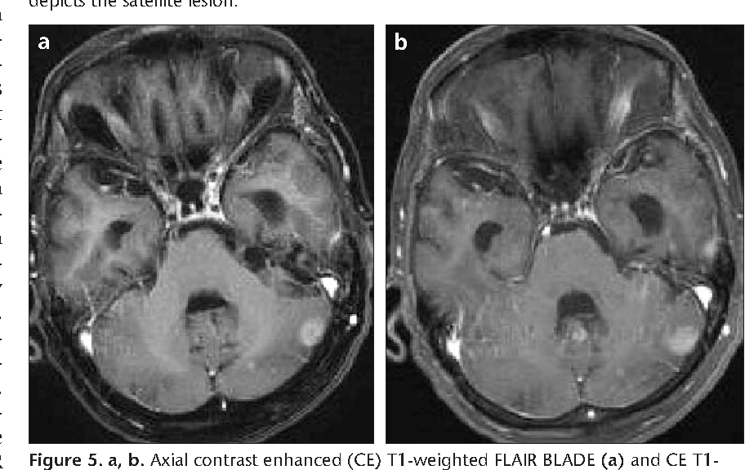The Gadolinium (talk about in detail below) is then administered in the body to perform its job as a paramagnetic contrast agent and reduces the T1 relaxation time and hence increases signal intensity to achieve the desired contrast.

Figure 7: A) Enhanced T1weighted image , B) T1 weighted image

# **Image Quality and Artifacts**

## Image Quality

Enhanced T1 MRI provides information that can’t be obtained using the normal T1-Weighted sequence. This information is extracted by certain models using the process mentioned above at obtaining a better image contrast. However the results depend also on the quality obtained by the selected model. So we always have to make certain of the fit quality chosen. After many studies two criteria are chosen to identify errors caused by poor fit FRI and FMI. The results indicate the superiority of the new criteria.

One technique widely used to verify fit quality is a visual comparison of model responses and calculated temporal data.

This research aimed at developing numerical parameters to determine the fit quality of a given model, using the autocorrelation function properties to resolve the random noise problem.

The above-mentioned methodology deduced that the limits of traditional standards are technically obvious because they do not distinguish the standard of fit and the SNR. Our analysis using simulated data shows that these theoretical limits create serious problems from procedures like CE‐MRI for analyzing the results. On average, the latest FMI and FRI parameters, over a wide range of SNR values, are less dependent on random noise compared to traditional criteria and are therefore more based on fit efficiency. The improvement provided by the new modeling error detection criteria was then checked with the real data.

The new FRI * and FMI * parameters suggest that model M1 is not appropriate for the whole series as it gives ludicrous fits. Consequently, FRI * and FMI * are useful to test the flow-limited model, or more generally to test the hypotheses used to simplify the M2 model. The new parameters allow one to check whether the model being evaluated can satisfactorily explain the results, taking into account the random noise in the data set. This explanatory ability depends on the model and tissue used, as well as the model's numerical integration, the initial parameters of the regression method chosen, and the procedure for the acquisition.

Errors may occur at all stages of the calculation, and the new standards allow one to check whether the calculation results are compatible with the data set. For example, the new criteria in studies of PC3 tumors in mice given Vistarem ® bolus injections suggest that M1 is suited to series of about 1 min, and that M2 is better adapted to series of about 10 min. This indicates that knowledge about permeability is being expressed in the data, but not within the first minute. FMI * and FRI *'s ability to differentiate fits only according to the a posteriori model shows that the temporally associated noise bc is low enough not to interrupt the tests.

## Image Artifacts:

### Subclavian Pseudo-stenosis Artifact

A focal irregularity in the stenosis mimicking the subclavian artery may occur ipsilaterally to the side of the contrast injection. It is a sensitivity (T2 *) reaction in the adjacent subclavian vein, due to residual gadolinium. Because of the long path of the left brachiocephalic vein the phenomenon is more often seen during left-sided injections. Subclavian pseudo-stenosis Incident of the left subclavian artery (arrow)due to sensitivity (T2 *) results of residual gadolinium in the venous contamination of the subclavian vein in MRA

Figure 8:Subclavian Pseudo-stenosis Artifact

### Scanning Too Late/Venous Contamination

Too late scanning gives time for venous return to occur, which overlaps the arterial process. It is especially troublesome in intracranial and cervical carotid systems where there may be substantial swelling of the dural sinuses and jugular veins within 5-10 seconds after the contrast bolus has arrived. Another place to observe rapid venous filling is the renal system.

Much like CTA, untimely CE-MRA gives only one chance to "get it right."

Figure 9:Scanning Too Late/Venous Contamination

### Scanning Too Early/Ringing (Maki) Artifact

If the central region of k-space is scanned before the contrast bolus arrives, the vessel will appear dark in the center, with only its edges displaying enhancement. The explanation for this presence immediately follows from the fact that the core of k-space defines the basic contrast of the picture while the periphery provides high spatial frequencies and information. Maki et al. originally defined this "too-early" phenomenon, and it is called the "Maki" or "ringing" artifact. As the other objects above, the maximum dosage of contrast was usually used before the artifact was found, and there is no other alternative left but to re-inject the patient, ideally in a certain setting.

**Gadolinium and its effects:**

Figure 10:Scanning Too Early/Ringing (Maki) Artifact

Enhanced T1 requires the use of a paramagnetic contrast agent called gadolinium-based contrast dye (GBCD) which is toxic in its free form to perform enhanced modified T1 image. It is tightly held by a binding agent, or chelator, to prevent the metal from depositing into the body to make gadolinium safe for use in humans. This drug, which is administered through a vein during the test, causes the relaxation time of T1 to be decreased and thus the signal strength increased. It is important to remember that the dye has many side effects and hazards as some recent studies have raised concerns that not all of the gadolinium injected for the scan is eliminated from the body, and that traces of gadolinium left in tissues can cause durable damage.

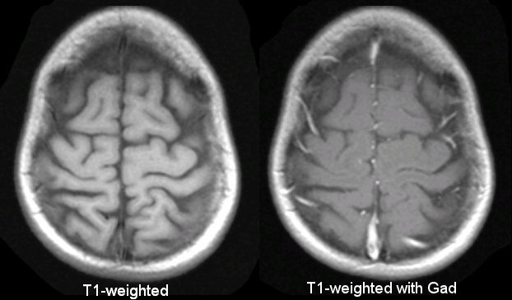

Figure 11:Difference between T1 weighted image with/without GAD

How GBCDs Work

Gadolinium is a chemical element that usually can not get through the blood-brain barrier when inserted into the bloodstream a network of membranes and cell processes that prevent blood substances from reaching the brain or spinal cord.

The blood-brain barrier is largely impermeable. However, the barrier is disrupted under certain circumstances, such as the active inflammation within the brain or the spinal cord that occurs during a relapse of MS (Multiple Sclerosis).

When this happens, gadolinium can enter the brain or spinal cord and, for instance, leak into an MS lesion, resulting in it appearing as a highlighted spot on an MRI.

Side Effects of GBCDs

Most of the Gadolinium-based Contrasts (GBCDs) side effects are mild, including:

1. Headache
2. Nausea
3. Dizziness
4. A cold sensation when injected

The possibility of the contrast material not being completely eliminated from the body is of more concern. There are also forms of gadolinium contrast in people with severe kidney failure, causing a serious disease called Nephrogenic Systemic Fibrosis. This disorder, which causes skin tightening and internal organ damage, is most likely to occur in people with MS who also have kidney dysfunction

# **Usefulness of Contrast-enhanced T1-weighted imaging**

Contrast-enhanced T1-weighted imaging is one of the most sensitive MRI techniques for detecting disease in the brain, It makes tumor boundaries much clearer and visible, Also Sensitive to presence of vascular or extravascular **Gd** and Useful for visualization of:

* Normal vessels
* Vascular changes
* Disruption of blood-brain barrier

# **(DWT-SVD) Method**

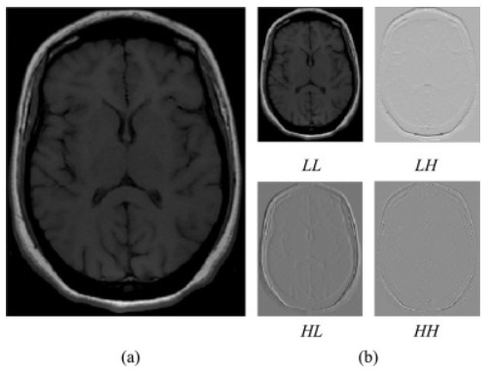In this part we present a updated Discret Wavelet Transform-Singular Value Decomposition (DWT-SVD) method for enhancing low contrast Brain MR Images used for brain tissue exploration. Specifically, we perform original image GHE first to have an equalized image with zero as mean and one as variance. All original and equalized images are decomposed into four sub-band elements , called Low-Low (LL), Low-High (LH), High-Low (HL), and High-High (HH) frequencies, using Discret Wavelet Transform (DWT). SVD is applied to both original and equalized image sub-bands of LL to produce three-matrix factorization (U , V and Σ), all of which are useful for measuring the correction coefficient (almost). Using an appropriate correction factor (available) to scale up the singular value matrix will enhance the low contrast T1-w MR images. Our contribution is this job, by using an empirically adjustable parameter (μ) to propose a new equation to compute the new enhanced singular value matrix image. Using Inverse DWT (IDWT) processes the resulting enhanced T1-w MR image was reconstructed as a final stage. The proposed technique could therefore improve, brighten and distinguish between different brain tissues with the promise of preserving unique edges and intensities information.

Figure 12:Image DWT decomposition; (a) Original T1-w MR image, (b) LL, LH, HL and HH sub-band images.

## Steps to execute main computational process of the proposed algorithm for enhancing the low contrast brain

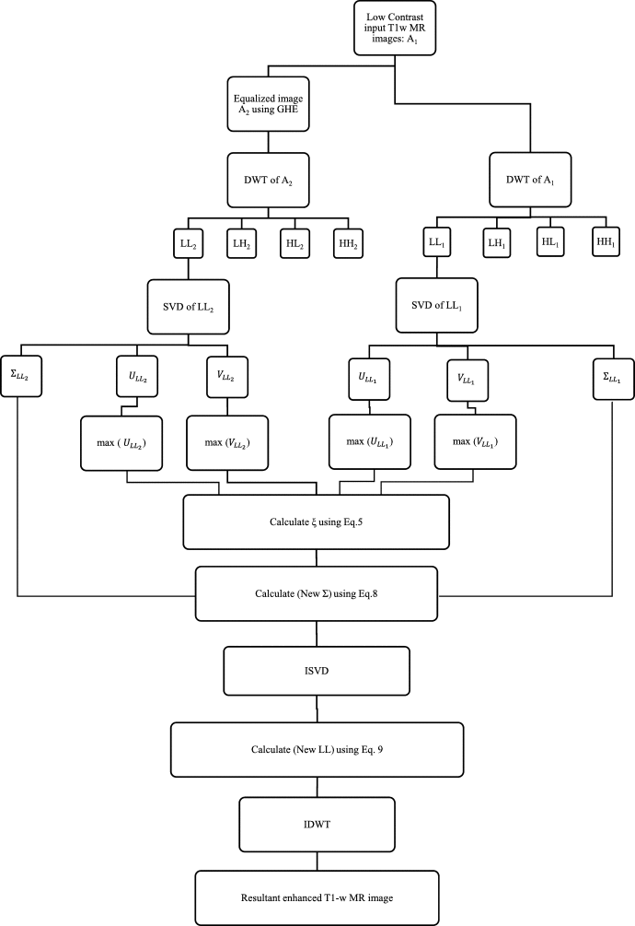

Figure 13:Global block diagram of the proposed enhancement algorithm

First, for the contrast enhancement approach a low contrast T1-w MRI image was selected then Equalizing T1-w MRI image (A1) using GHE technique to produce equalized image (A2) with zero as mean and one as variance.

After equalization, DWT calculates the decomposition of both the original image (A1) and the equalized image (A2) to divide each image into four frequency sub-band images which are (LL1), (LH1), (HL1), (HH1) and (LL2), (LH2), (HL2), (HH2) respectively then applying SVD to both low frequency components (LL1) and (LL2) leading to three-matrix factorization U, V and Σ :

* Where *U* and *V* are m⁎m and n⁎n orthogonal matrix respectively and Σ is m⁎n diagonal matrix containing singular values on its diagonal.

After SVD, calculating the maximum of (U1) and (V1) from (LL1) and the maximum of (U2) and (V2) from (LL2) then, calculating the correction factor (ξ) using

Estimating the (New Σ), which is a weighted sum of the singular value matrix of the original() and the equalized sub-band images () multiplied by an adjustable parameter (μ) empirically determined between the range of 0.05 and 0.95 using

Applying Inverse SVD to generate (New LL) using

Finally, applying Inverse DWT to obtain enhanced resultant T1-w MRI image.

## Results

The subjective qualities of the used techniques are shown in the following figures

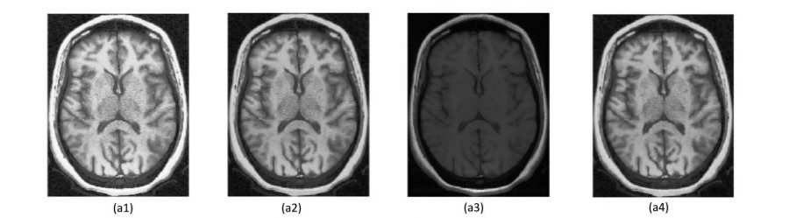

Figure 14:Enhanced images using different contrast enhancement methods and one of them (DWT-SVD) Method

# **Applications**

1. Improving Infectious and Neoplastic Meningitis Detection
2. Detection of Cerebral Metastases and Brain Tumors:

* Enhanced T1 Weighted image significantly increases the contrast of lesions and thus could improve the detection rates of small lesions in early stages of the disease.

1. Use of contrast-enhanced intraoperative T1-weighted MRI to identify residual tumors in glioblastoma surgery:

* 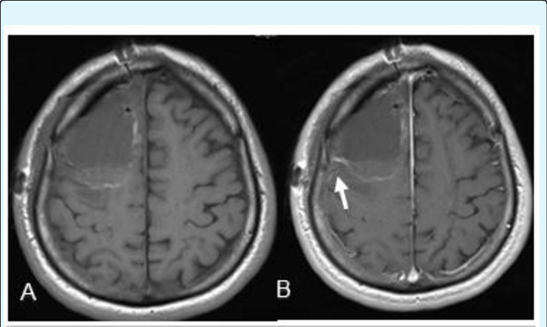Intraoperative dynamic contrast-enhanced MRI provides fast, reproducible, high-quality, and clearly interpreted dynamic MR images in the intraoperative environment, and can help distinguish surgically induced enhancement from residual tumor.

Figure 15:glioblastoma resection Edema and hemorrhage along resection cavity representing post-surgical changes

1. Prostate cancer: Evaluation of vascular characteristics using dynamic contrast-enhanced T1-weighted MR imaging

**References**

* Research Gate, 2015. [Online]. Available: https://www.researchgate.net/post/Does_anyone_know_what_is_contrast-enhanced_T1-weighted_images_and_whats_the_difference_between_this_and_T1-weighted_image. [Accessed: 22- May- 2020].
* "MRA artifacts (CE)", Questions and Answers ​in MRI, 2018. [Online]. Available: http://mriquestions.com/mra-artifacts-ce.html. [Accessed: 20- May- 2020].
* "Article - Contrast-enhanced MRI of the Abdomen and Pelvis", Appliedradiology.com, 2018. [Online]. Available: https://appliedradiology.com/communities/MR-Community/contrast-enhanced-mri-of-the-abdomen-and-pelvis. [Accessed: 24- May- 2020].
* U. Bashir, "Contrast enhanced MR angiography | Radiology Reference Article | Radiopaedia.org", Radiopaedia.org, 2017. [Online]. Available: https://radiopaedia.org/articles/contrast-enhanced-mr-angiography?lang=gb. [Accessed: 26- May- 2020].
* Kammer NN, Coppenrath E, Treitl KM, Kooijman H, Dietrich O, Saam T (2016) Comparison of contrast-enhanced modified T1-weighted 3D TSE black-blood and 3D MP-RAGE sequences for the detection of cerebral metastases and brain tumours. Eur Radiol 26:1818–1825
* "Article - Usefulness of Contrast-Enhanced T1-weighted Sampling Perfection With Application-Optimized Contrasts by Using Different Flip Angle Evolutions in Detection of Small Brain Metastasis at 3T MR Imaging: Comparison With Magnetization-Prepared Rapid Acquisition of Gradient Echo Imaging", AJNR. American journal of neuroradiology. Available: https://pubmed.ncbi.nlm.nih.gov/19213825/. [Accessed: 27 - May- 2020].